**Documentation for Extracting Images, Logos, ColourCharts by Supplier Code**

**I) How to Run the Script**

1. Just double click on the **‘extract.exe’** file which is present in the folder **Extraction Script.**
2. Choose the **‘csv’** file that you want to load.

Example: Master-Catalogue.csv

1. Now choose the **type of extraction** that you want to perform from the dropdown list.

Example: Image, Colour Chart, Logos

1. After you select the extraction type from the dropdown list, **Press OK**
2. Choose the **source folder** from where the files should be extracted.

Example:

H:\CATALOGUE 2014\Logos High res – for Logos

H:\CATALOGUE 2014\Product Images high res – for images

H:\CATALOGUE 2014\Colour Charts high res – for Colour Charts

1. Just **wait** for the script to complete.
2. The extracted folder ( **Images, ColourCharts or Logos** ) are now present in the same folder as ‘extract.exe’ (in step 1)
3. There are two extra files created :
   1. Logfile – which lists all the processes that the script performed
   2. Error-file – if a file is present but cannot copy for some reasons, error-file lists that file

**II) Dependancies**

These modules are listed as a rescue if something goes wrong. However, these do not have to be installed before running the script.

1. Python 2.7

This is the scripting language on which entire script is based. It can be downloaded from [here.](https://www.python.org/ftp/python/2.7/python-2.7.amd64.msi)

1. Tkinter

It is a python based module responsible for the dialog boxes to select filename and directories. It must be already installed with Python 2.7 but in case there is a problem, you can download it from [here](http://tkinter.unpythonic.net/wiki/How_to_install_Tkinter).

1. Others

Other dependancies like shutil, csv, stat, time, etc are already shipped with Python 2.7.

**III) Screenshots**

1. Contents of **Extraction Script** folder. The folders **build** and **dist** are most important folders. Do not touch these folders. **Test.csv** is just a test csv file.

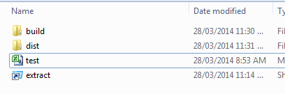

1. Dialog Box to Open the csv file.

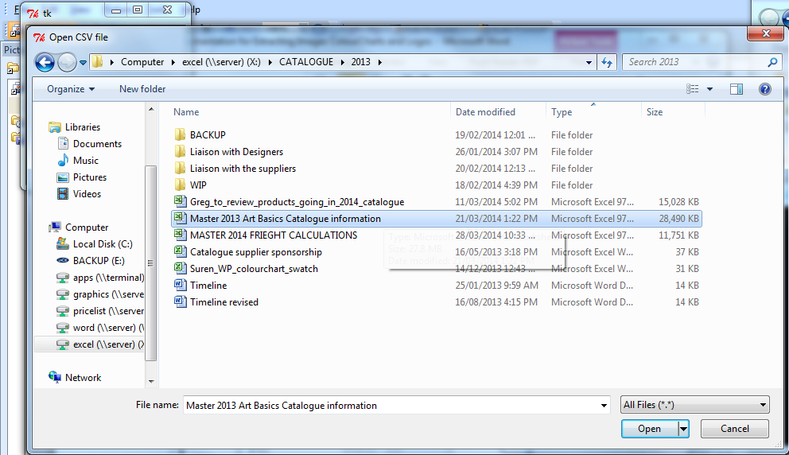

1. Dialog box to choose the Extraction Type. Choose any one from the drop down and Press OK

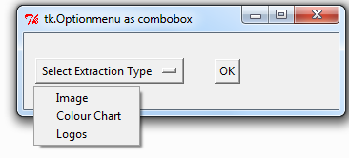

1. Dialog box to choose the source folder from where the files should be extracted.

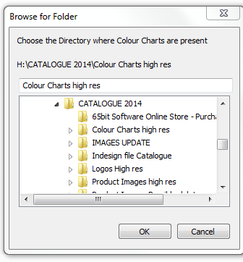

1. Script during execution.

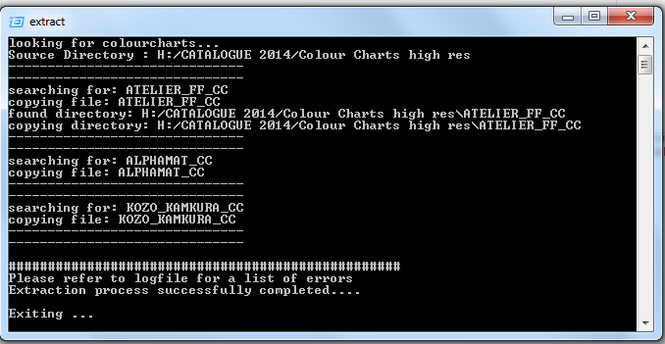

1. Final folder structure of Extraction Script after executing the program. Note that the folder **ColourChart** has been created with two additional files **error-file.txt** and **logfile.txt**

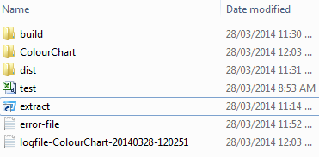

1. Folders inside ColourChart are named with supplier code which then contains the extracted files.

